Project 2.2.3 Windmill Construction

Introduction  As you know from your science class or Energy and the Environment unit, a windmill converts wind energy to a useful mechanical energy. One real-world use of a windmill is to grind grain into flour. The rotary movement of the sail, turned by the wind, changes the direction of motion by 90º.  Equipment  - Engineering notebook  - Pencil  - VEX kits | 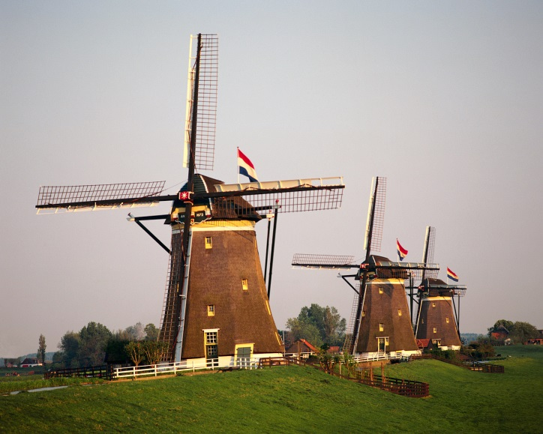

Procedure
Using your knowledge of the mechanisms recently built in class, design and build a solution to situation A, described below. Then modify your solution to solve the problems described in B. Each of the situations requires a change in direction of motion by 90º but requires a different input/output speed relationship. Each of the structures you build will need to incorporate a mechanism to change the direction of output and possibly the input/output speed relationship. Your structure must be stable, rigid, and must hold the gears in proper relationship to each other.

Sketch: In your engineering notebook, sketch what your first solution should look like. Label the input and output and present your sketch to your instructor before you begin building.

A) The output speed and torque are equal to the input speed and torque.
Mechanism’s name: __________________

B) The output speed is < (less than) the input speed, but the output torque is greater.
Mechanism’s name: __________________

Conclusion
- Which of the mechanisms that you have modeled in class can be used to:
  - Increase torque and decrease speed –
  - Increase speed and decrease torque –
  - Keep constant speed and torque –
  - Transmit rotary movement at a 90 degree angle –
  - Reverse the flow of power –

- What is the purpose of an idler gear?

